

**RESEARCH**

**PLAN:**

**SIMPLIFIED**

**RESTAURANT**

**ANALYSIS**



POPULARITY

ANALYSIS:

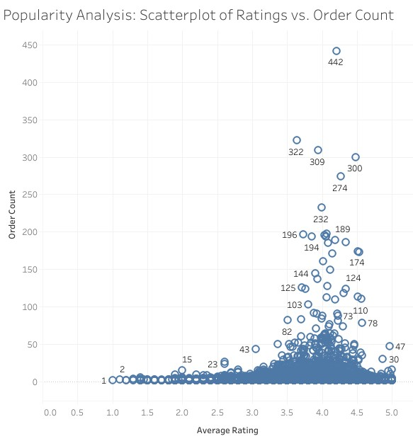

**Concentration**

:

Most restaurants cluster between

an average rating of 3.5

-

5

and low order counts

(<100).

**Outliers**

:

High showing customer satisfaction

drives popularity.

Order counts (>300) correlate with high

ratings (4.5

-

5)

, indicating popular, well

-

rated

restaurants.

**Trend**

:

Higher ratings strongly align with

higher order counts,



**Key Findings:**



REVENUE ANALYSIS

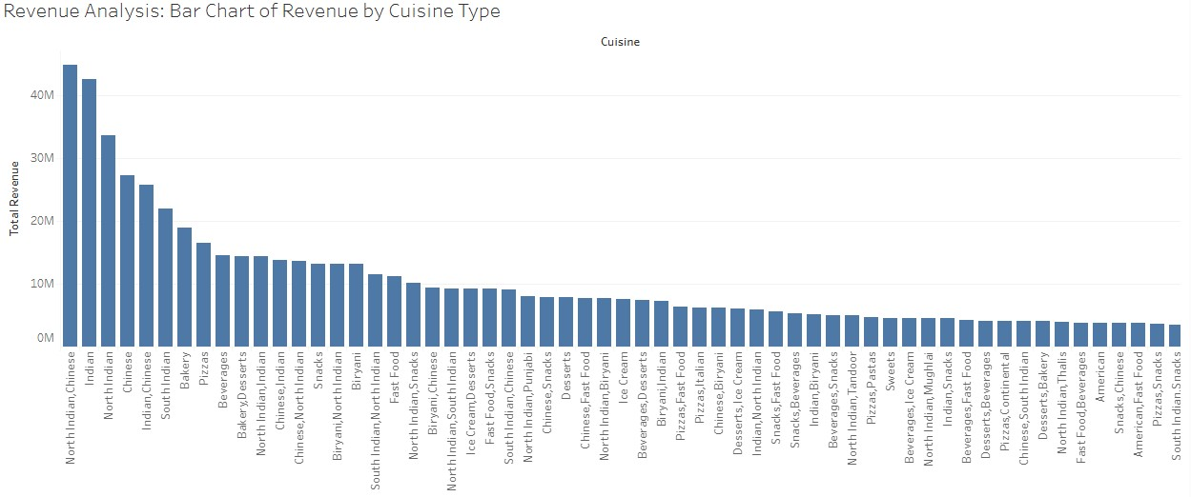

**Key Findings:**

•

**Top Revenue**

**-**

**Generating Cuisines**

:

North Indian

and Chinese cuisines dominate, with over 40M in

revenue each, showcasing strong popularity.

•

**Mid**

**-**

**Tier Revenue Cuisines**

:

South Indian, Bakery,

and Beverages are significant contributors but

generate less revenue than the top cuisines.

•

**Low Revenue Cuisines**

:

Desserts and snacks

generate lower revenues, reflecting niche

appeal or limited demand.



LOCATION

TRENDS

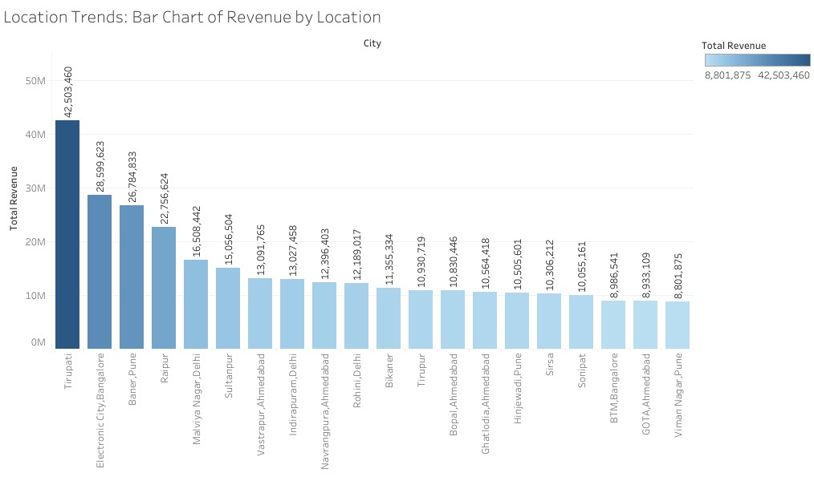

•

**Top Locations**

:

Tirupati, Electronic City, and Bangalore lead

in total revenue, with Tirupati generating over 42M.

•

**Mid**

**-**

**Tier Locations**

:

Cities like Banjara Hills and Malviya

Nagar contribute moderate revenue, between 15M

-

27

M.

•

**Low**

**-**

**Performing Locations**

:

Locations like

Viman

Nagar

Pune and GOT A Ahmedabad generate under 10M, indicating

weaker demand.



**Key Findings:**



SEASONAL

TRENDS

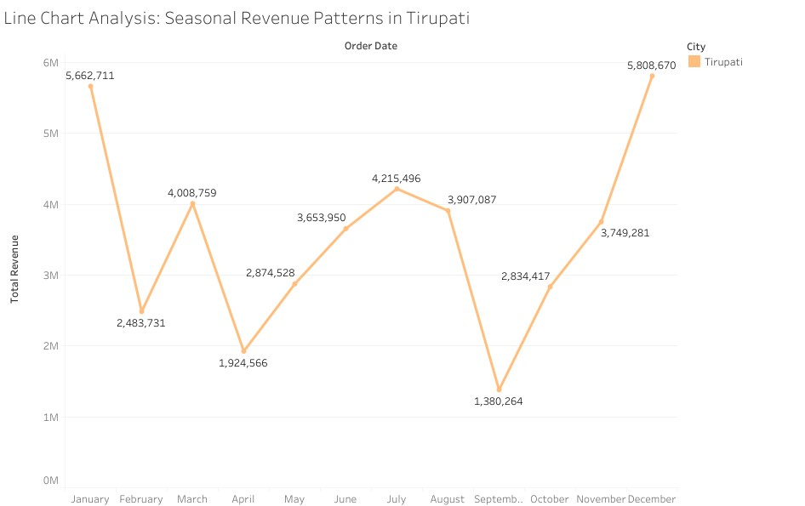

**Seasonal Peaks**

:

Revenue in Tirupati shows

clear peaks in January and December,

reaching over 5.6M and 5.8M, respectively.

**Seasonal Lows:**

September's revenue was just

1.38

M, indicating a significant dip. Fluctuating

Trends: Revenue varies throughout the year,

with moderate performance in other months

like March and June.

**Key Findings:**



DASHBOARD

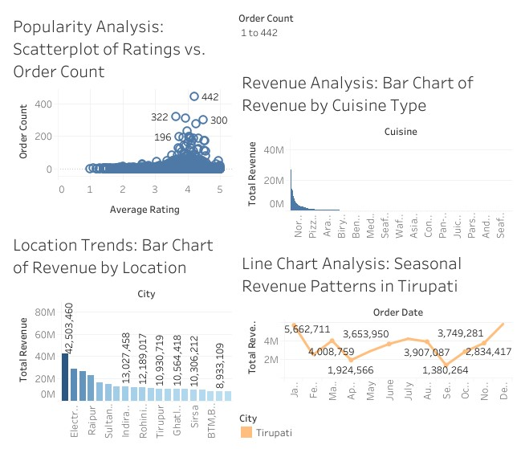

# FINAL CONCLUSIONS AND RECOMMENDATIONS

**Popularity Analysis (Scatterplot):**



Conclusion:

* Customer ratings strongly impact restaurant popularity, as higherrated establishments tend to have more orders.
* Restaurants with ordinary ratings (below 3.5) generally struggle with order volume, emphasizing the importance of maintaining quality and satisfaction.

**Recommendations:**

* Focus on improving service quality for restaurants with ratings below four stars to increase order potential.
* Study the operational practices of top-performing outlier restaurants.
* Consider implementing a review improvements program for restaurants with low ratings but decent order volumes.

**Revenue Analysis (Bar Chart):**

**Conclusions**:

* **Demand Dominance:** North Indian and Chinese cuisines are the primary revenue drivers, likely due to their broad customer appeal.
* **Opportunity for Growth:** Mid-tier cuisines like South Indian and Bakery show potential for scaling with targeted efforts.
* **Specialized Offerings:** Low-performing cuisines may serve as complementary options or require innovation to boost appeal.

**Recommendations:**

* Expand marketing for top-performing cuisine types into new markets.
* Consider consolidating or rebranding lower-performing cuisine categories.



Final Conclusions AND

RECOMMENDATIONS



**Key Findings from Visualizations:**



**Location Trends (Bar Chart):**

**Conclusion**

-

Major revenue comes from a few top

-

performing cities,

highlighting high concentration in specific regions.

-

Mid

-

tier locations have the potential for growth with

targeted strategies.

-

Low

-

performing areas require further analysis to identify

challenges or untapped opportunities.

**Recommendations**

:

-

Investigate successful practices in Tirupati for

potential replication.

-

Develop market penetration strategies for lower

-

performing cities.

-

Consider resource reallocation to high

-

potential

markets.



**Seasonal Trends / Revenue Analysis (Line chart):**

**Conclusion**

-

There is a strong seasonal demand in Tirupati during

January and December, likely due to festivals or

tourism.

-

September represents a potential off

-

season or low

-

demand period.

**Recommendations:**

-

Develop special promotions to boost sales during low

seasons.

-

Plan resource allocation based on seasonal patterns.

-

Creating marketing campaigns to capitalize on peak

seasons.



SEASONAL STRATEGY

•

**High Allocate additional resources, such as staffing, inventory, and marketing campaigns, to**

**handle increased demand in January and December Season Focus**

:

•

Allocate additional resources, such as staffing, inventory, and marketing campaigns, to handle

increased demand in January and December.

•

Offer premium packages or festival

-

themed promotions to capitalize on the high influx of customers.

•

**Low Season Recovery**

:

•

Introduce discounts, loyalty programs, or limited

-

time offers in low

-

performing months like September

to attract customers.

•

Collaborate with local events or tourism boards to drive more traffic during off

-

peak seasons.

•

**Balanced Promotion**

:

•

During moderate months, focus on sustaining steady revenue through targeted campaigns, ensuring

consistent customer engagement.

# METRIC BASED INSIGHTS

•**Popularity Score**:

•Use the **Popularity Score** (Order Count × Rating) to identify top-performing restaurants.

•Prioritize marketing and investment in these restaurants to further enhance their performance.

•**Average Order Value (AOV)**:

•Calculate **AOV = Total Revenue / Order Count** for each restaurant.

•Focus on strategies to increase AOV, such as upselling combos, premium menu items, or addons.

•**Target Underperformers**:

•Identify restaurants or cuisines with low popularity scores or AOV.

•Offer staff training, optimize menus, or improve customer experience to increase ratings and drive higher revenue.

•**Location Optimization**:

•Rank cities or regions based on aggregated popularity scores and AOV.

•Allocate more marketing efforts and investment to high-scoring areas while revising strategies for underperforming locations.

•**Benchmarking**:

•Set thresholds for metrics like AOV and Popularity Score to benchmark restaurant performance.

•Regularly review and compare trends to adjust operational or marketing strategies effectively.